CIS 2109

Scott O’Hara

Homework 2

6.60)

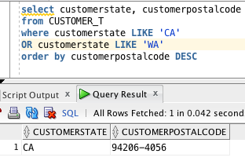

6.64)

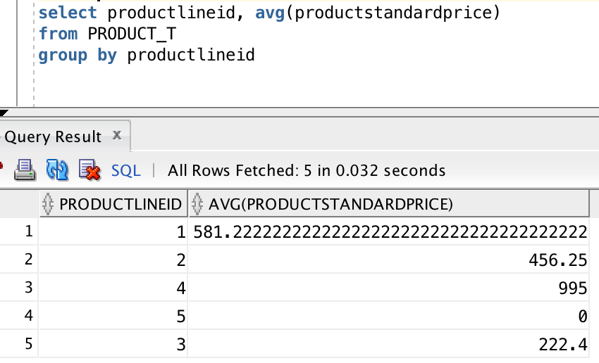

6.65)

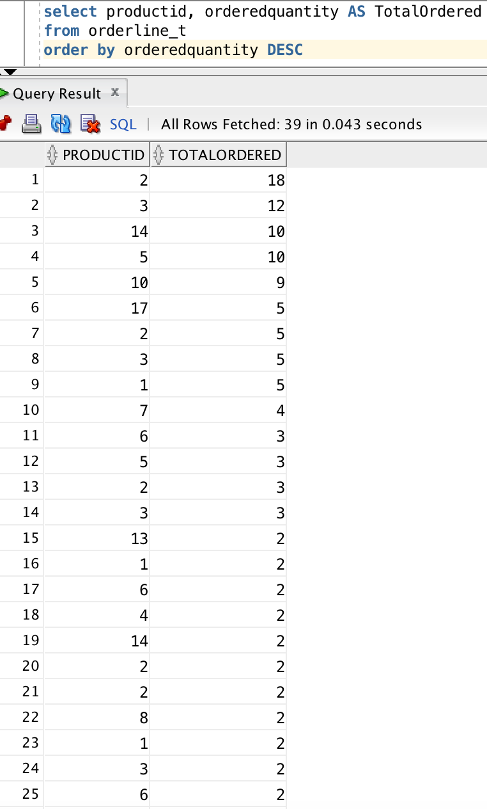

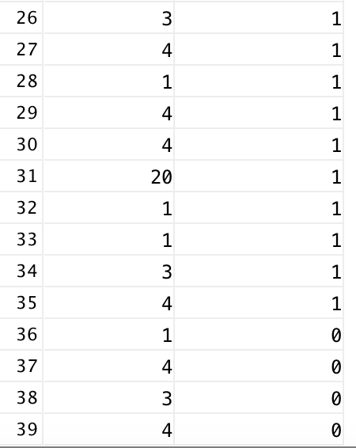

6.66)

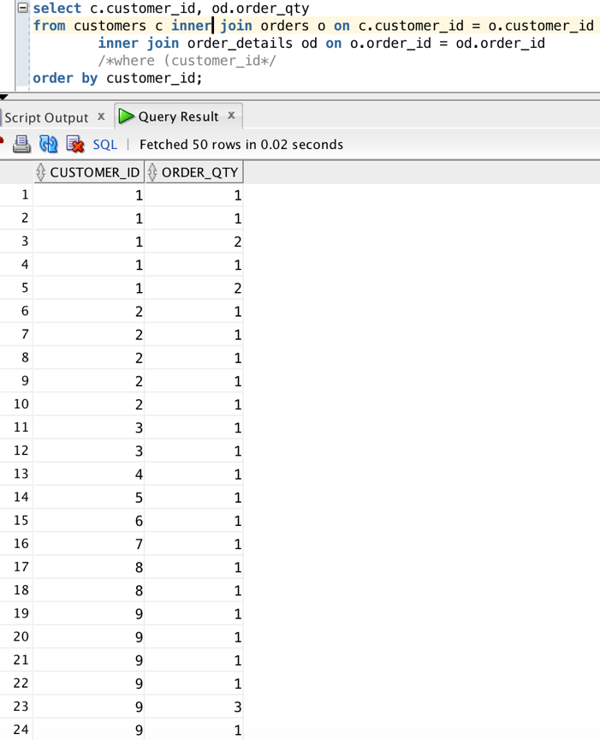

6.67)

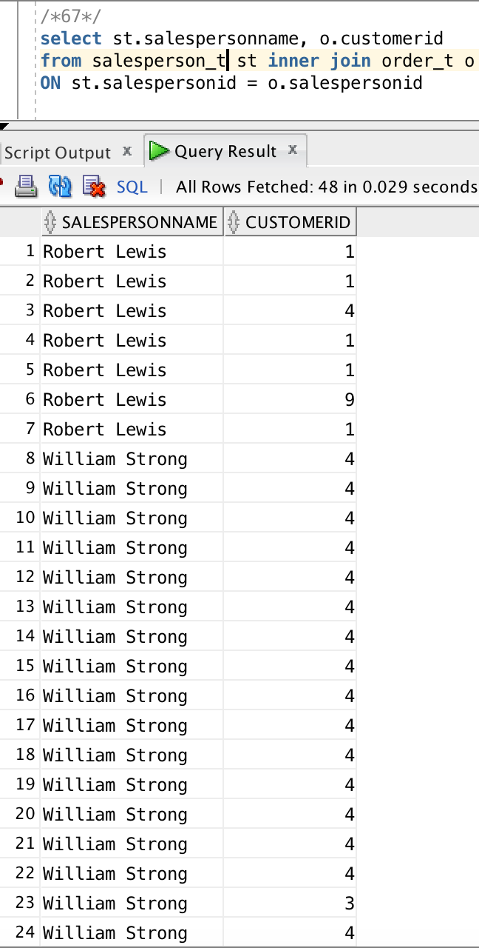

//finished for midterm

6.68) Display the product ID and the number of orders placed for each product. Show the results in decreasing order by the number of times the product has been ordered and

label this result column NumOrders.

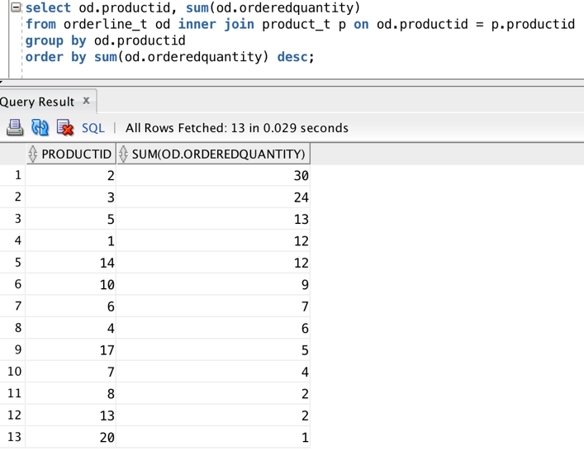

//Ran out of time

6.70)For each salesperson, list the total number of orders.

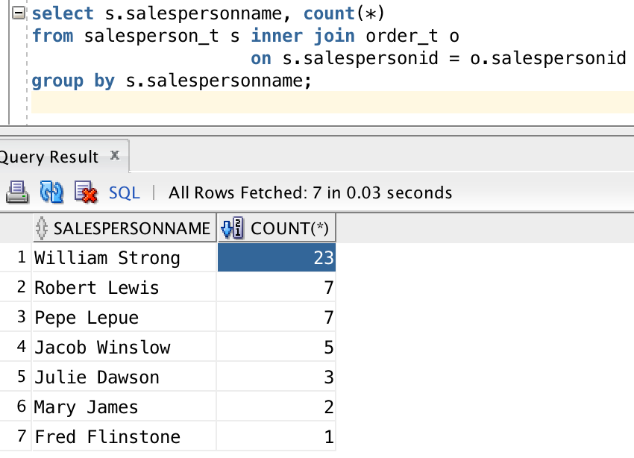

6.71) For each customer who had more than two orders, list the CustomerID and the total number of orders placed.

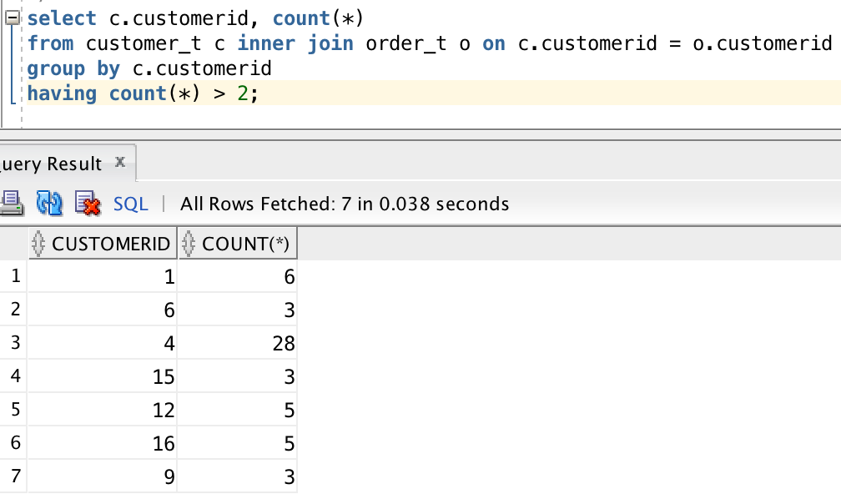

6.75) Display the territory ID and the number of salespersons in the territory for all territories that have more than one salesperson. Label the number of salespersons NumSalesPersons.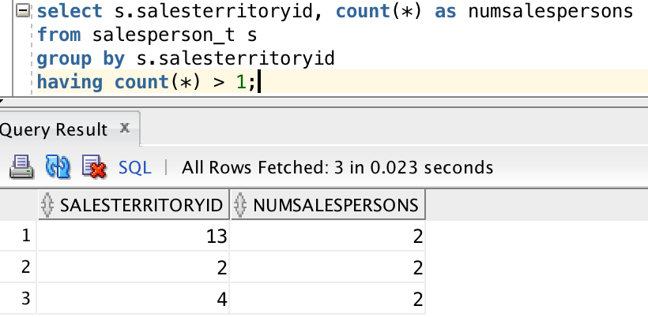

6.79) List ProductID, ProductDescription, ProductFinish, and ProductStandardPrice for oak products with a ProductStandardPrice greater than $400 or cherry products with a StandardPrice less than $300. Show how you constructed this query using a Venn diagram.

